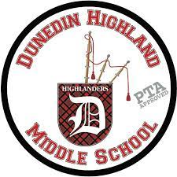Dunedin Highland Middle

6th-8th ESE ACCESS TEAM

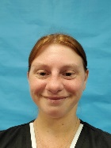 **Mrs. Sarah Pruitt, Science, Social Studies**

**PruittSA@pcsb.org**

Mrs. Pruitt loves anything science! She earned a degree in Criminology from the University of South Florida before deciding to transition into teaching. Since then, she never looked back and loves working with kids with special needs. Mrs. Pruitt has taught at the elementary and middle school, working with ESE students i grades K-8 with a variety of exceptionalities for the past eight years. She is passionate about teaching her students skills they can use in the classroom as well as in real life in the future.

In her life away from school, Mrs. Pruitt loves to take nature walks with her family and do wildlife photography. She is an avid reader, crafter, and is always up for trying something new. She loves watching the Tampa Bay Lightning (GO BOLTS!). It is also no surprise that being a Lightning fan, her favorite color is blue. She is excited to get to know all her new students and families at Dunedin Middle this year.

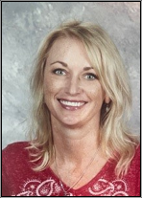 **Mrs. Jennifer Timmons, ELA, Art**

**TimmonsJE@pcsb.org**

Mrs. Timmons has a BA in Art from Kennesaw State University and an MA in Varying Exceptionalities from the University of South Florida. Her 20 years of teaching experience ranges from primary grades to college, but middle schoolers are her favorite. Her passion is integrating art and sensory experiences into her academic classes and ensuring ALL students reach their potential in communication skills.

Mrs. Timmons earned the Dunedin Mayor’s Top Apple Award for her students’ achievement in the Arts. Her students have exhibited their artwork at many shows in Pinellas County.

Mrs. Timmons is happily married with five kids. Three of her kids have been to DHMS; her youngest is an 8th grader this year. She has older kids at East Lake High, SPC, working locally, and serving in the Navy. She has been busy this summer fostering kittens. She enjoys reading, taking art classes, and boating.

Mrs. Timmons partners with the *Kiwanis Club* to run the ***DHMS Builder’s Club*** and manage the school **Clothing Closet.** She and her husband volunteer with the **PTA** and work to sell the advertisement banners in the front of the school. (If you have a business you would like to advertise, please let her know!)

 **Mrs. Deborah Lake, ELA/Elevate Reading**

**LakeD@pcsb.org**

Ms. Lake has been teaching for twenty-four years, fifteen of those in Pinellas Couty. She has taught a variety of middle and high school Intensive reading and Access Point education classes. She has a master’s degree in Varying Exceptionalities K-12 from the University of South Florida. She is certified in Reading, ESE, ESOL, and Middle Grades Social Studies.

Ms. Lake has a passion for reading and going to the movies. She loved coaching the Special Olympics in the past. She roots for the BUCS, Bulls and Bolts. She loves connecting to her students. Ms. Lake loves her family and her cat Bella!

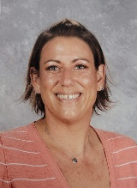 **Mrs. Jennifer Rossell, Math, Unique Skills**

**Rossellj@pcsb.org**

Mrs. Rossell is entering her 8th year at Dunedin Highland Middle School, and her 8th year teaching. Mrs. Rossell graduated from St. Petersburg College of Education with Honors in 2014 and began teaching Intensive Reading at DHMS that fall. Mrs. Rossell earned her master's degree in Curriculum Design and Instructional Technology in 2019. She first joined the DHMS MMI Team in 2017 and thrives in the self-contained classroom. This year, Mrs. Rossell is excited to be teaching Math and Unique Skills to the students in the DHMS MMI program, after acting as Media Specialist and Technology Coordinator for the school over the past two and a half school years. She is ready to get back into the classroom!

Mrs. Rossell has two kids of her own, Rylan, who is about to turn 13, and Remy, who is 7. The Rossell family enjoys road trip vacations, playing mini-golf and spending as much time at the pool as the weather will allow!

Mrs. Smith and Mrs. Rossell will be partnering with ***Feeding Tampa Bay*** to offer DHMS families a **Food Pantry** on campus this year.

 **Mrs. Linda Smith, Behavior Specialist**

**SmithLind@pcsb.org**

Mrs. Smith has worked at Dunedin Highland Middle for 14 years. Prior to that, she was at Clearwater High School for 13 years as the On Campus Intervention Program teacher. She also spent over 12 years working with high-risk teens with Family Resources Inc., and at Brookwood Residential Home. Mrs. Smith graduated from Ohio University with a Bachelor of Science; and is certified in ESE K-12, Integrated Curriculum and is Reading Endorsed. She is CPI and First Aid certified.

Mrs. Smith loves working with our students at DHMS. Every day, she will give 110%, always showing up with a positive attitude and a smile. Students and teachers know they can count on her to support and help them through difficult situations.

Mrs. Smith’s husband, Scott, works in the social work field. She has three grown daughters, and two grandchildren, with two more on the way. Her two dogs, Ruby and Wall-E, and Phoebe the cat, complete her family. Her favorite places are Honeymoon Island and her back porch.

Mrs. Smith and Mrs. Rossell will be partnering with ***Feeding Tampa Bay*** to offer DHMS families a **Food Pantry** on campus this year.

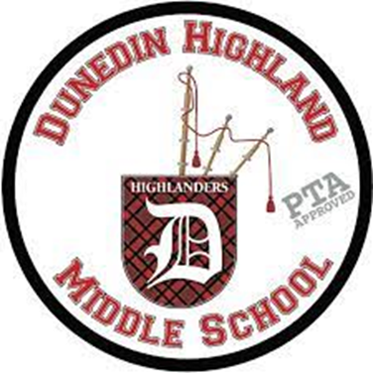**My Supplies for School**

Check them off as you get them! 

|  |  |
| --- | --- |
| Pencils |  |
| C:\Users\timmonsje\AppData\Local\Microsoft\Windows\INetCache\Content.MSO\F304B1B5.tmpColored Pencils  and/or  Markers |  |
| C:\Users\timmonsje\AppData\Local\Microsoft\Windows\INetCache\Content.MSO\87EC91AD.tmp  Small 3-Ring Binder  (½ or 1 inch) |  |
| 3+ Kleenex C:\Users\timmonsje\AppData\Local\Microsoft\Windows\INetCache\Content.MSO\F79CCB6C.tmpC:\Users\timmonsje\AppData\Local\Microsoft\Windows\INetCache\Content.MSO\F79CCB6C.tmp |  |
| C:\Users\timmonsje\AppData\Local\Microsoft\Windows\INetCache\Content.MSO\51847DC1.tmp  Glue Sticks |  |
| Clothes Icon | Free SVG / PNG, Premium Animated GIF / APNG Customizable  Icons · Loading.io  Change of Clothes  (for an emergency) |  |

 Dunedin Highland Middle

ESE Access Team Resources

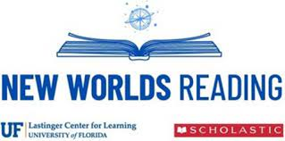

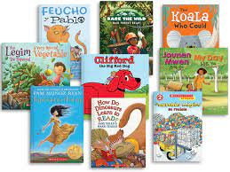**Free Books!**

Go to [www.newworldsreading.com](http://www.newworldsreading.com) to sign your child up for FREE books. Student number is not required. Just select their interests and the approximate reading level (**not actual grade level**) for the books. They will send you free books in the mail monthly!



**The Sherlock Library** – Free online adapted versions of classic and popular books for kids and teens.

<https://w3.ric.edu/sherlockcenter/wwslist.html>

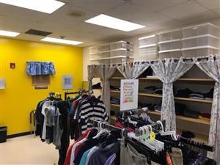**Builders Threadz – Clothing Closet**

The Kiwanis Club of Dunedin has partnered with the DHMS Builders Club to establish **Builders Threadz** - a clothing closet for the Dunedin Highland Middle School community.

**Mrs. Timmons** will be running the club and working with Access Students to run and manage the store. Students will learn valuable life and work skills as they help out.



**Highlander Helping Hands Food Pantry**

Feeding Tampa Bay has partnered with DHMS to provide an on campus food pantry for DHMS families. **Mrs. Rossell and Mrs. Smith** will be working with Access students to manage and run the food pantry. Students will learn a variety of job skills while working in the food pantry.